**Progress Report**

**Abubakar Sarwar K132212**

**Sarim Mumtaz K132364**

**Taha Rafi Alvi K132050**

**Humza Khatri K132104**

**Jaffer Raza Zaidi K132272**

**Section E**

**Submitted to Sir Imran Zafar**

**Software Engineering Project**

**FAST University**

**1.0 EXECUTIVE SUMMARY**

The initial problem was to solve the problem of controlling and centralizing the security like door locks etc. and the electrical appliances like lights, fans etc. We are doing this task by developing an application. Up till now we have done with the designing part. We have designed the logo, the timeline page (used to show different devices connected), the login page (used to connect and centralize a user) and we have also done with the splash screen. Basically we have worked on the UI of the application. The problem was not as simple as it seems. Initially we have added some dummy devices for the check but later on we will add all the potential devices which can be included. So far we have only worked on the basic infrastructure of the user interface while later on we will focus on increasing the responsiveness, color scheme and we will also cover the aspects like animation based on the actions performed by the users. So overall all the pages have been designed and have been linked with each other and a basic infrastructure has been created based on the problem. We have also done with most of the documentations and diagrams related to the OOAD like class diagram etc.

**2.0 GROUP PROGRESS AND MILESTONES ACHIEVED**

Hard amount of work has been given to the project so far by every single individual member of the project. Starting of with one of the toughest milestones for every member,,

2.1 Requirement Gathering

Quality is defined by meeting the customer’s requirement. We wanted our project/application to have high quality. Hence, we worked alot in gathering the correct and specified requirements for our project. Unlike others, we didn’t just waste time in guessing what a customer would need for a security app like we are creating. We literally talked to different individuals and shared our project with them then asked them about the functions and features that they would desire. Obviously, most of them were very vague and difficult for us to understand. Hence, we picked out the most accurate, common and achievable requirements that the customers wanted. We wanted to make a survey on it but we were unable to do so.

2.2 Designing The Project

A project cannot be initiated if we don’t design it properly. Hence, we used all of the OOAD skills that we had to design the project by making it’s Class Diagram, Sequence Diagram, Use Case Diagram and even State Chart Diagram. All these diagrams helped us to analyze our own problem domain better than before and even helped us in recognizing the features and functions that will be a part of our project. Screenshots of the diagrams have been provided below:

Class Diagram

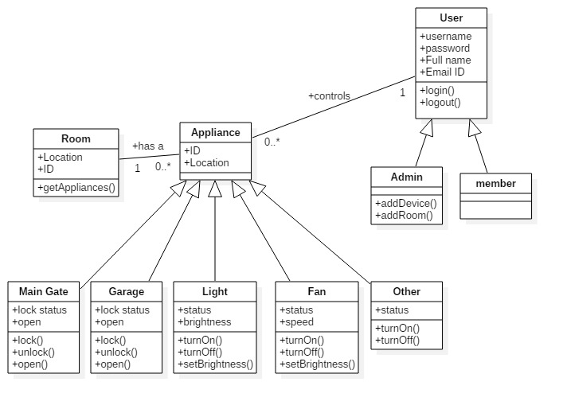

Sequence Diagram

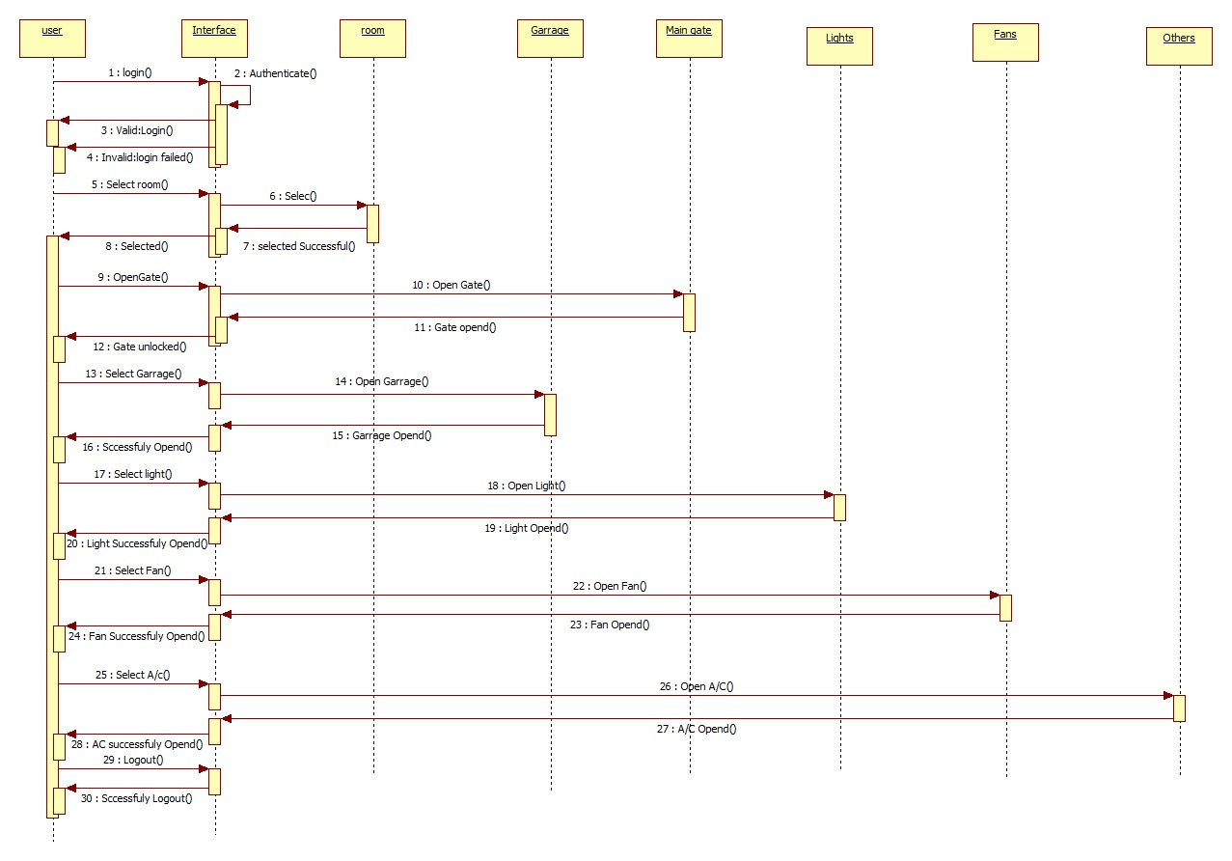

State Chart Diagram

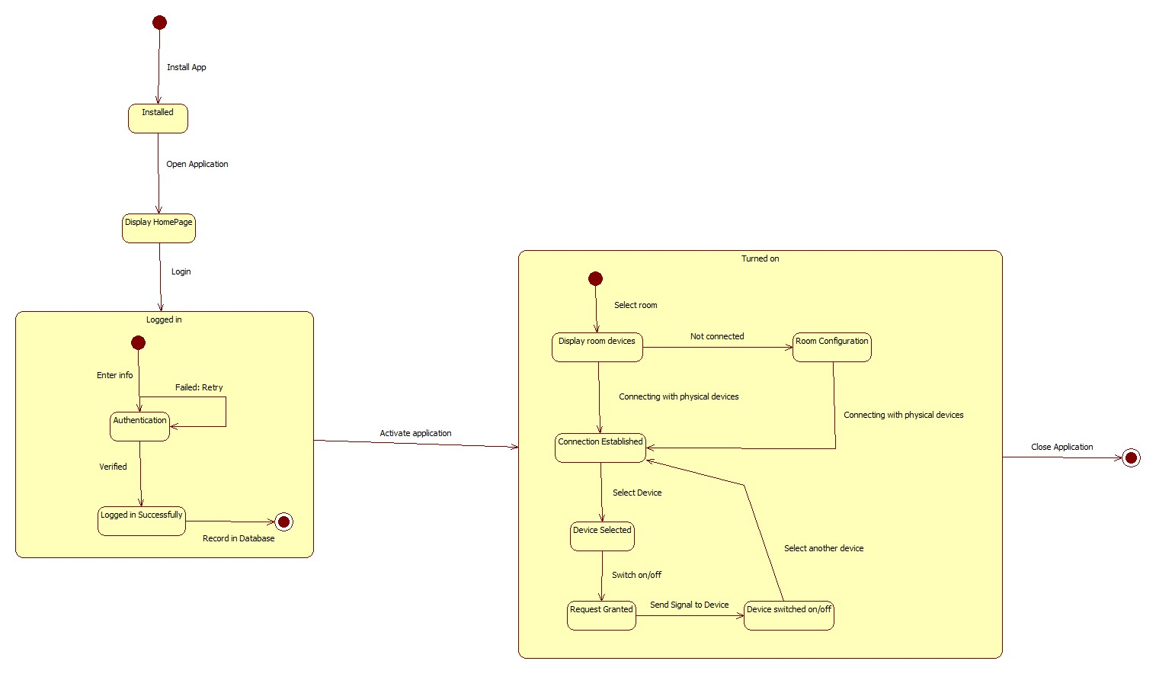

Use Case Diagram

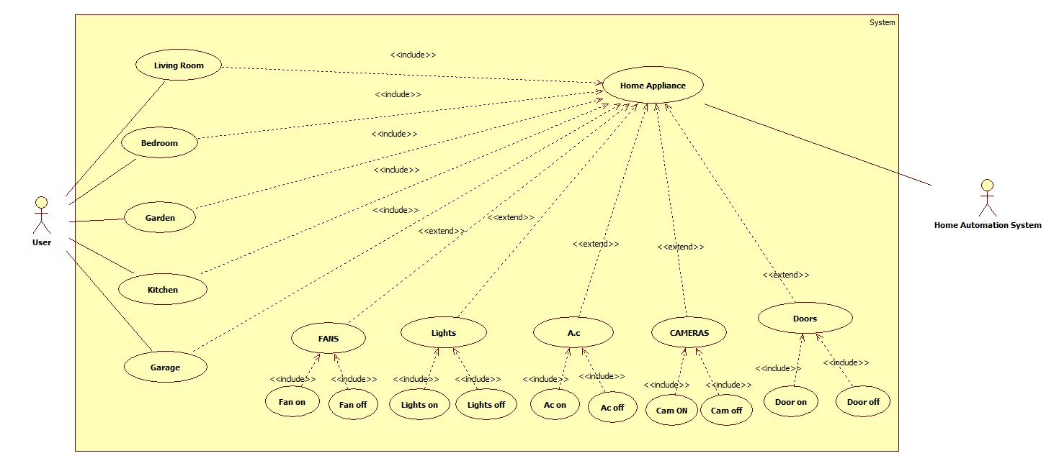

2.3 Learning Android Development and Android Studio

None of the team members were aware about Android Development at the start of the project. However, it was necessary to build an android application for us because of the current scope and importance of the language. Hence, every single team member has learned how to work on Android Studio, and also have achieved a very good understanding level of the android development. This was the first and essential milestone that was necessary to achieve in order to make our project successful. Below are some screenshots of the work that we have done so far at the Android Studio. It’s just a slight glimpse of the effort that was put on by the project members of the group.

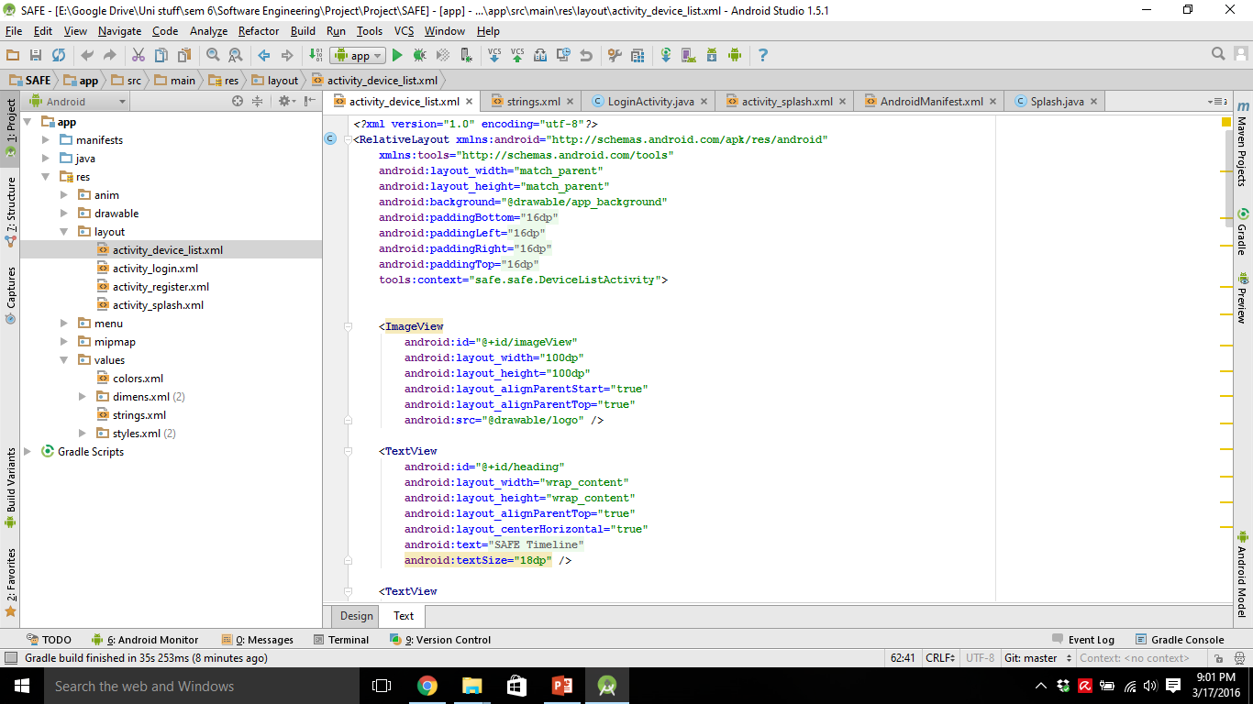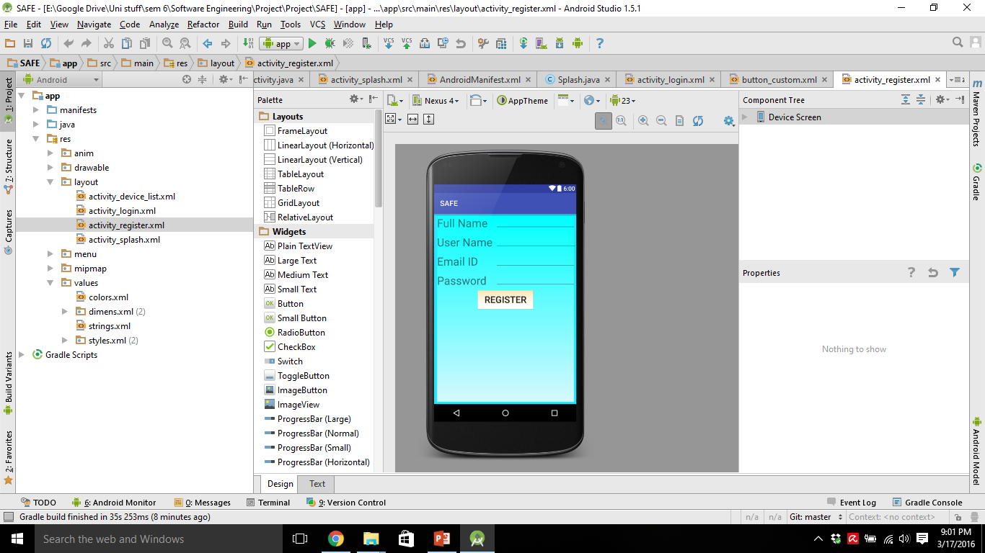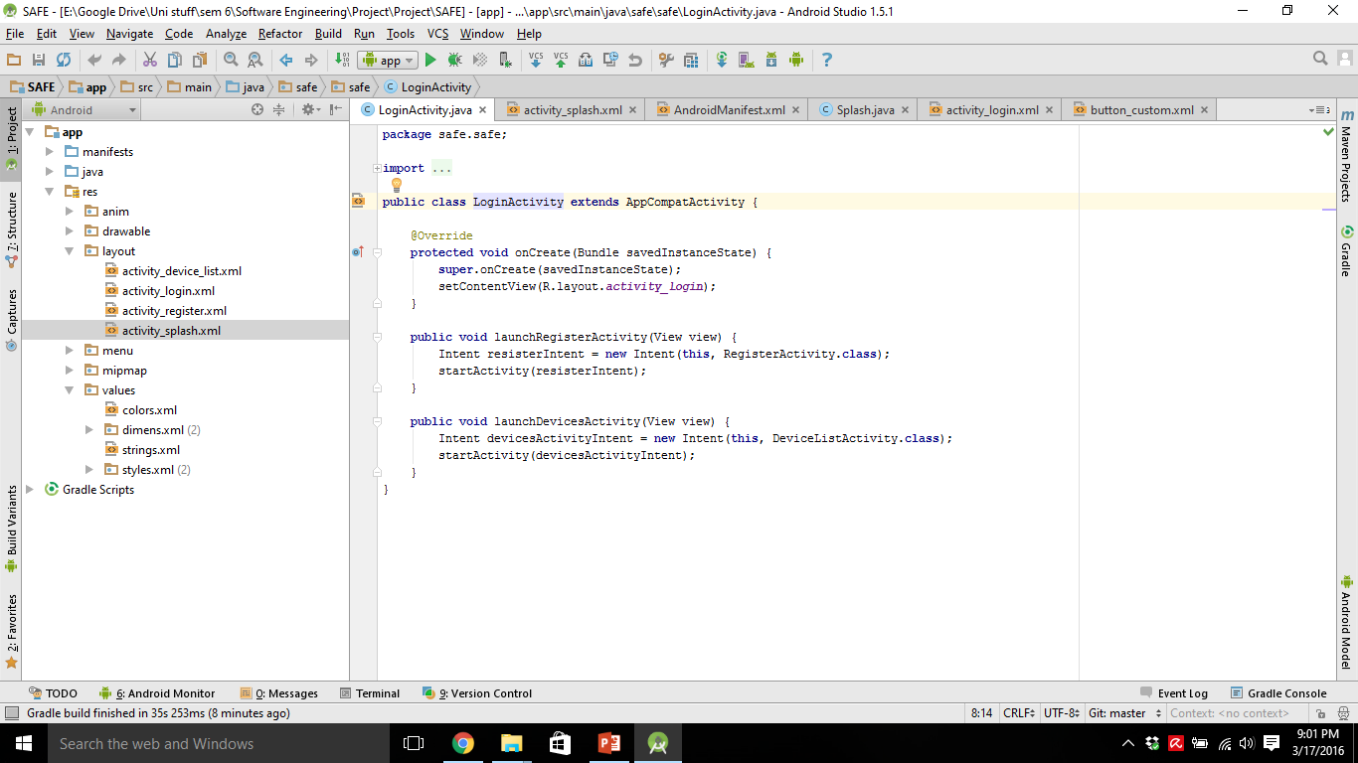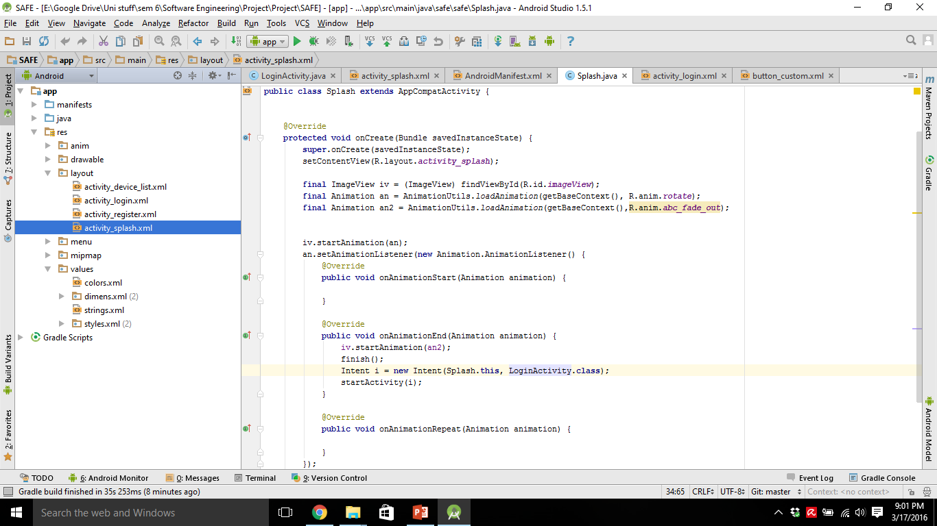

2.4 Creating the interface for the project

Interface is the main attraction of the user. Everyone wants their project to have a very attractive and user friendly interface for the customers that will be using the applications. However, we are new to android development. Hence, we have created a much simpler interface. The reason for that is simply because we wanted the application to be more user friendly. The main reason to create this app is to provide security and ease for the customer. So complex layouts won’t be suitable for this kind of application. Below are some screen shots of the interface once the application was build and run on my very own Android Phone Samsung Galaxy Note 2.

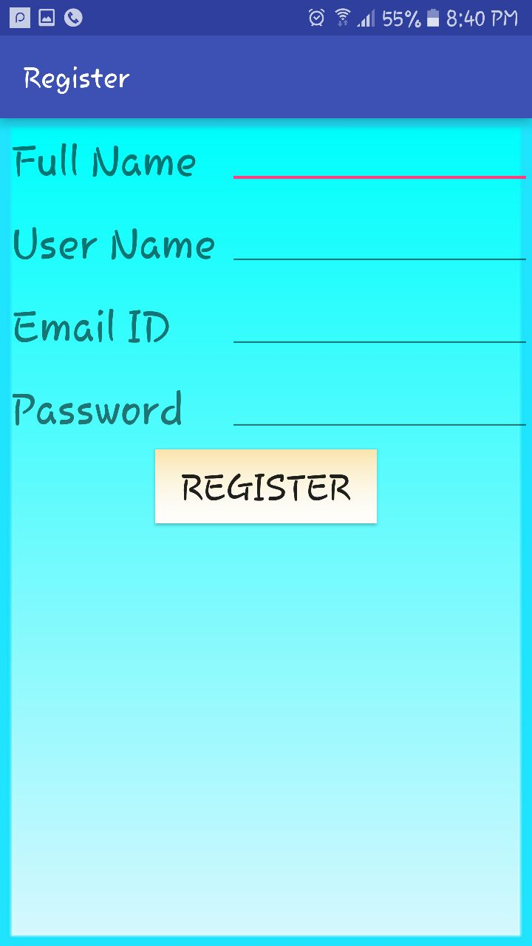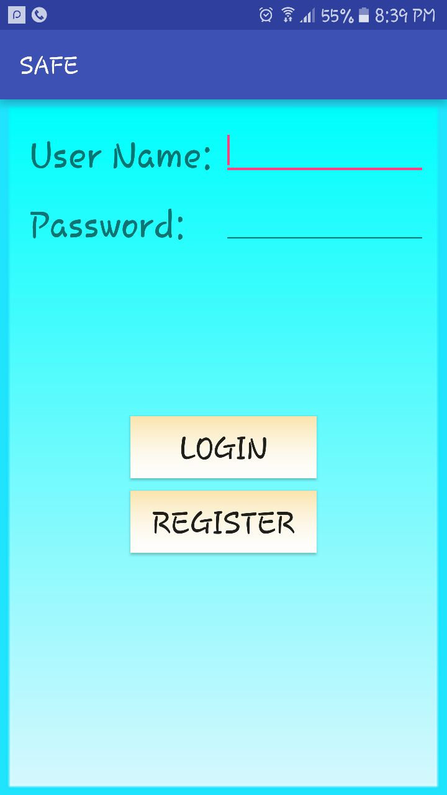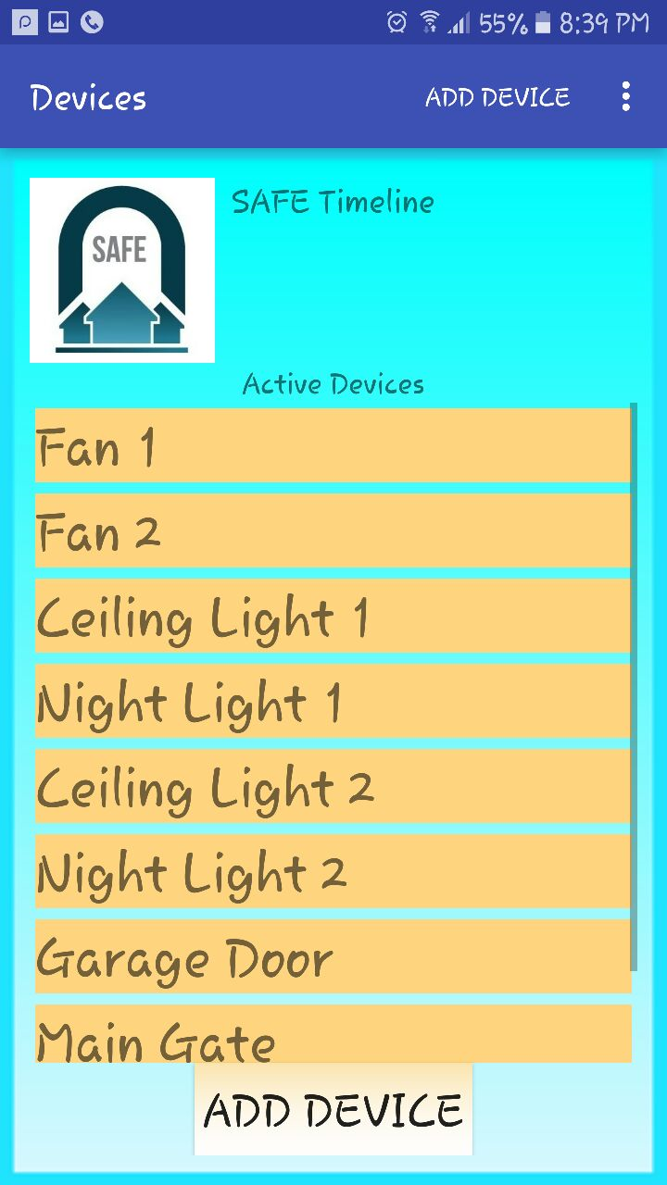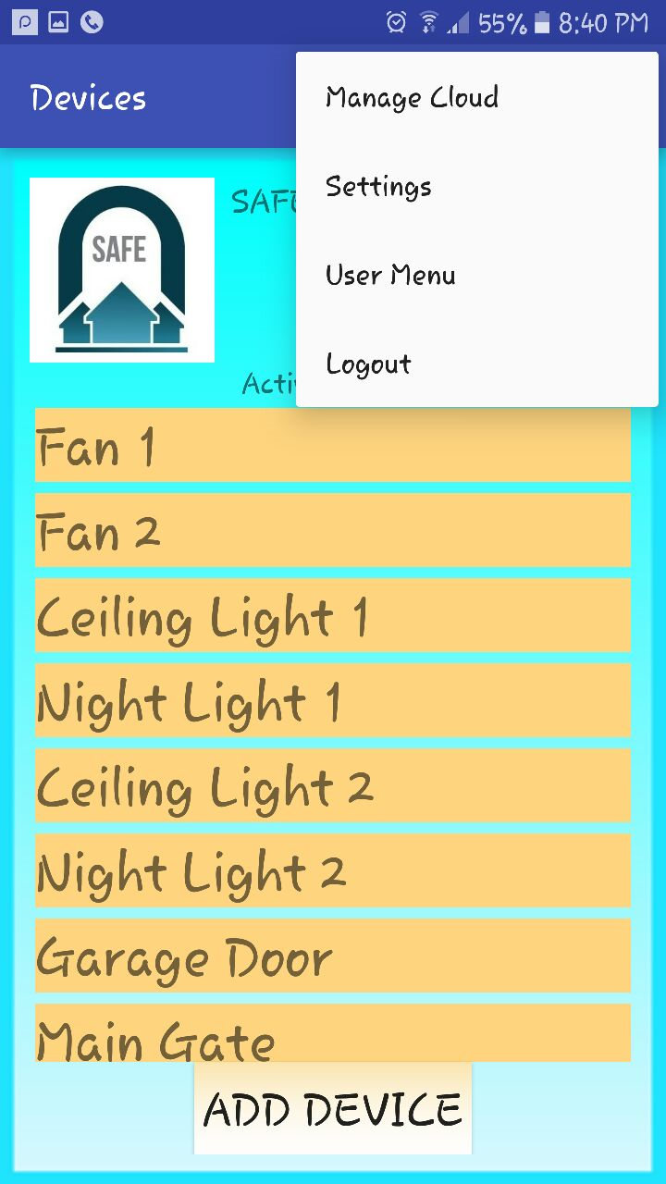

2.5 Logo Design

An application is not going to attract a user if your logo is very simple or not something special. We have literally worked on the logo by applying professional Logo Designing skills on the project. We made a couple of logos for the project, but after alot of arguments we finally concluded and have agreed upon the following logo:



(Please Note: This new logo is still awaited to be incorporated with the interface. So the interface screenshots above has the old logo which we will replace with this new fancy logo.)

**3.0 CHALLENGES FACED:**

This project, as the requirement suggests, is based on android and although we are familiar with java we faced a few challenges. Development on android is very different from what we have done in the past. First of all, we had to learn the extensive library of classes and functions that java provides in order to make what we thought of. Using these classes for our own benefit is bit daunting at first, but comes along very nicely overall. Going through this learning curve was very exhausting but rewarding. Getting to what you need is quite a challenge, so one has to come up with workarounds that do not modify the requirements too much and go with the implementation well.

Secondly, XML is a totally new markup language that we had to learn in order to make the user interfaces. This is very similar to HTML that we have done in the past but there are some key differences, for example the styling method is very different. This required us to learn and tackle the challenges it takes to learn a new language.

Since this is our first time building an app for a mobile device, the process looked quite different from what we are used to. Setting up android studio was a challenge in itself. Deciding to use virtual devices revealed hardware problems and didn’t go well with the agile approach we were going for. So we decided to use physical devices and debug the application that way. Constantly running the app on the device to make sure we get the functionality we are hoping for.

There were off course other challenges as well. Collaborating on git hub was a first time for us. Managing the versions and keeping it all in line was a nice experience and we learned long the way.

**4.0 REMAINING WORK AND FUTURE PLANNINGS:**

Up till now the interfaces for the user have been defined. The user can now have a clear idea and see what the final structure of the app interface will look like. The next step would be to create the back-end of the application. This will have the user database and the devices database, that will be responsible for storing and managing the device and user data. This will also provide security that will come as the user authentication and administration privileges.

This app provides a solid platform for anyone who is interested in making a self-contained home automation system. This app is a very solid base to provide the user with the experience to have control for his entire home.

Since this app is aimed at handling all the user stories, the next logical step would be to provide the necessary interfaces for it to connect and control appliances. This could very well be Bluetooth, wifi, radio or any other technology that is both reliable and robust. Because these are already available in any android phone/table in the market, it would be easy to integrate the interface with the application.

Secondly, the hardware required to run this project is out of the scope of this project, as a matter of fact, it is out of the scope of computer science. So, this should be the next step which will nicely bring together all the aspects of the project. The hardware would include a micro controller network that will talk to the phone via the interface mentioned above. These micro controllers will then be responsible to directly control the appliance the user wants to control. These devices could include transistors and relays that would play nicely with the appliances and control them at the user’s command.